**Progressive Duplicate Detection**

**ABSTRACT:**

Duplicate detection is the process of identifying multiple representations of same real world entities. Today, duplicate detection methods need to process ever larger datasets in ever shorter time: maintaining the quality of a dataset becomes increasingly difficult. We present two novel, progressive duplicate detection algorithms that significantly increase the efficiency of finding duplicates if the execution time is limited: They maximize the gain of the overall process within the time available by reporting most results much earlier than traditional approaches. Comprehensive experiments show that our progressive algorithms can double the efficiency over time of traditional duplicate detection and significantly improve upon related work.

**EXISTING SYSTEM:**

* Much research on duplicate detection, also known as entity resolution and by many other names, focuses on pairselection algorithms that try to maximize recall on the one hand and efficiency on the other hand. The most prominent algorithms in this area are Blocking and the sorted neighborhood method (SNM).
* Xiao et al. proposed a top-k similarity join that uses a special index structure to estimate promising comparison candidates. This approach progressively resolves duplicates and also eases the parameterization problem.
* Pay-As-You-Go Entity Resolution by Whang et al. introduced three kinds of progressive duplicate detection techniques, called “hints”

**DISADVANTAGES OF EXISTING SYSTEM:**

* A user has only limited, maybe unknown time for data cleansing and wants to make best possible use of it. Then, simply start the algorithm and terminate it when needed. The result size will be maximized.
* A user has little knowledge about the given data but still needs to configure the cleansing process.
* A user needs to do the cleaning interactively to, for instance, find good sorting keys by trial and error. Then, run the progressive algorithm repeatedly; each run quickly reports possibly large results.
* All presented hints produce static orders for the comparisons and miss the opportunity to dynamically adjust the comparison order at runtime based on intermediate results.

**PROPOSED SYSTEM:**

* In this work, however, we focus on progressive algorithms, which try to report most matches early on, while possibly slightly increasing their overall runtime. To achieve this, they need to estimate the similarity of all comparison candidates in order to compare most promising record pairs first.
* We propose two novel, progressive duplicate detection algorithms namely progressive sorted neighborhood method (PSNM), which performs best on small and almost clean datasets, and progressive blocking (PB), which performs best on large and very dirty datasets. Both enhance the efficiency of duplicate detection even on very large datasets.
* We propose two dynamic progressive duplicate detection algorithms, PSNM and PB, which expose different strengths and outperform current approaches.
* We introduce a concurrent progressive approach for the multi-pass method and adapt an incremental transitive closure algorithm that together forms the first complete progressive duplicate detection workflow.
* We define a novel quality measure for progressive duplicate detection to objectively rank the performance of different approaches.
* We exhaustively evaluate on several real-world datasets testing our own and previous algorithms

**ADVANTAGES OF PROPOSED SYSTEM:**

* Improved early quality
* Same eventual quality
* Our algorithms PSNM and PB dynamically adjust their behavior by automatically choosing optimal parameters, e.g., window sizes, block sizes, and sorting keys, rendering their manual specification superfluous. In this way, we significantly ease the parameterization complexity for duplicate detection in general and contribute to the development of more user interactive applications.

**SYSTEM ARCHITECTURE:**

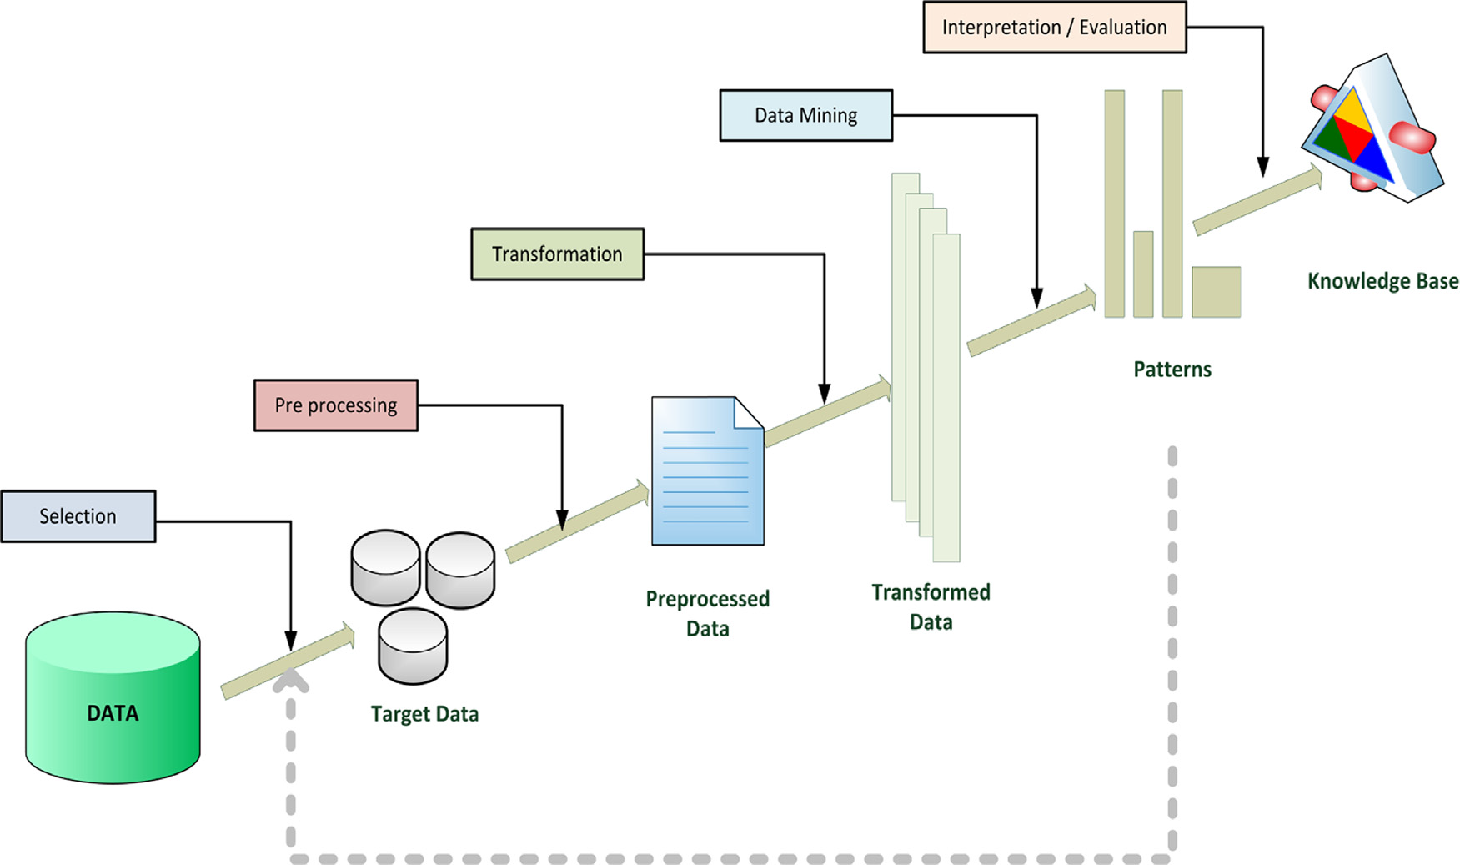

**Data Separation**

**Duplicate Detection**

**MODULES:**

* Dataset Collection
* Preprocessing Method
* Data Separation
* Duplicate Detection
* Quality Measures

**MODULES DESCSRIPTION:**

**Dataset Collection:**

To collect and/or retrieve data about activities, results, context and other factors. It is important to consider the type of information it want to gather from your participants and the ways you will analyze that information. The data set corresponds to the contents of a single database table, or a single statistical data matrix, where every column of the table represents a particular variable. after collecting the data to store the Database.

**Preprocessing Method:**

Data Preprocessing or Data cleaning, Data is cleansed through processes such as filling in missing values, smoothing the noisy data, or resolving the inconsistencies in the data. And also used to removing the unwanted data. Commonly used as a preliminary data mining practice, data preprocessing transforms the data into a format that will be more easily and effectively processed for the purpose of the user.

**Data Separation:**

After completing the preprocessing, the data separation to be performed. The blocking algorithms assign each record to a fixed group of similar records (the  
blocks) and then compare all pairs of records within these  
groups. Each block within the block comparison matrix represents the comparisons of all records in one block with all records in another block, the equidistant blocking, all blocks have the same size.

**Duplicate Detection:**

Theduplicate detection rules set by the administrator, the system alerts the user about potential duplicates when the user tries to create new records or update existing records. To maintain data quality, you can schedule a duplicate detection job to check for duplicates for all records that match a certain criteria. You can clean the data by deleting, deactivating, or merging the duplicates reported by a duplicate detection.

**Quality Measures:**

The quality of these systems is, hence, measured using a cost-benefit calculation. Especially for traditional duplicate detection processes, it is difficult to meet a budgetlimitation, because their runtime is hard to predict. By delivering  
as many duplicates as possible in a given amount of time, progressive processes optimize the cost-benefit ratio. In manufacturing, a measure of excellence or a state of being free from defects, deficiencies and significant variations. It is brought about by strict and consistent commitment to certain standards that achieve uniformity of a product in order to satisfy specific customer or user requirements.

**SYSTEM REQUIREMENTS:**

**HARDWARE REQUIREMENTS:**

* System : Pentium IV 2.4 GHz.
* Hard Disk : 40 GB.
* Floppy Drive : 1.44 Mb.
* Monitor : 15 VGA Colour.
* Mouse : Logitech.
* Ram : 512 Mb.

**SOFTWARE REQUIREMENTS:**

* Operating system : Windows XP/7.
* Coding Language : JAVA
* IDE : Netbeans 7.4
* Database : MYSQL

**REFERENCE:**

Thorsten Papenbrock, Arvid Heise, and Felix Naumann, “Progressive Duplicate Detection”, **IEEE TRANSACTIONS ON KNOWLEDGE AND DATA ENGINEERING, VOL. 27, NO. 5, MAY 2015.**